Task Management Tool

Introduction
Project Name: Task Management Tool
Goal: To design and develop an efficient task management system that allows users to create, assign, and track tasks effectively.
Role: UX/UI Designer and Developer
Tools Used: Figma, Adobe XD.
Team Members:
- Madhumathi S
- Jothiga S
- Kaviya K
- Sethuraman A
- Santhosh P

Problem Statement
In today’s fast-paced world, individuals and teams struggle to manage multiple tasks efficiently.
Traditional methods like notebooks or spreadsheets are not dynamic, lack reminders, and fail to support collaboration.
The goal of this project is to provide a digital solution that enhances productivity, simplifies task tracking, and encourages teamwork.

User Research
Research Methods: Online surveys, interviews, and competitor analysis.
Key Insights:
- 80% of users prefer mobile-friendly task management tools.
- Users value notification reminders and color-coded priorities.
- Simplicity in design is a top priority for user satisfaction.
Findings:
A user-centered design with minimal steps for task creation and updates enhances engagement and efficiency.

Information Architecture
The app structure includes:
1. Dashboard – Overview of all tasks and progress.
2. Task List – Detailed view of tasks with categories.
3. Calendar – Visual display of tasks by date.
4. Settings – User preferences and notifications.
5. Profile – Personal details and activity summary.

User Flow / Journey
1. User logs into the system.
2. Navigates to the Dashboard to view active tasks.
3. Adds a new task with details (title, deadline, priority).
4. Marks tasks as completed when done.
5. Receives reminders for pending tasks.
6. Reviews task progress through analytics.
UI Design
The high-fidelity UI design uses:
- Primary Colors: Blue and White for clarity and professionalism
- Typography: Poppins and Roboto for readability
- Components: Cards, progress bars, buttons, and modals for interaction

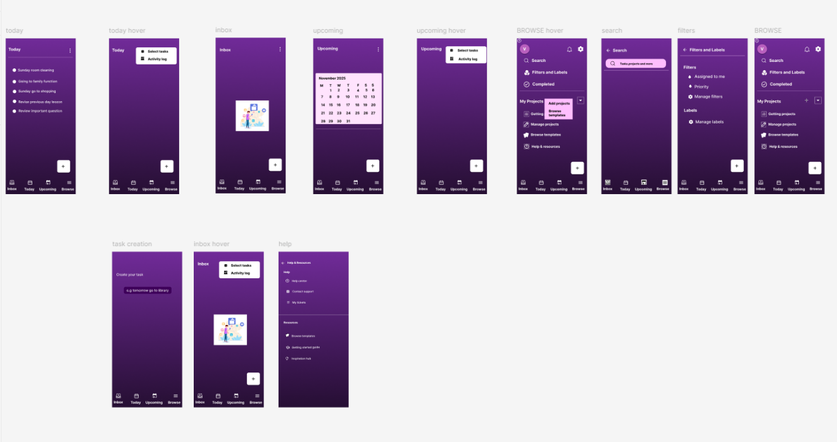

Prototype & Interactions
Interactive prototypes were created in Figma to demonstrate task creation, completion, and calendar navigation.
Transitions and animations were added for a smooth and engaging user experience.

Conclusion
The Task Management Tool successfully addresses the problem of inefficient task handling and boosts productivity.
By integrating an intuitive interface and user-friendly design, the project provides a practical and scalable solution for individuals and teams.
Thank you for reviewing this project.

